

STARS

Security Tools And Reporting System

for Windows

Guide for Completing the

INCIDENT COMPLAINT REPORT

SECTION I – ADMINISTRATIVE

This section is to be used for the recording of information that is applicable to the entire report (e.g., incident number, date of incident). An incident is defined as one or more offenses committed by the same offender (or group of offenders acting in concert at the same time and place. Although multiple offenders, victims, etc., sections can be submitted for each report, only one Administrative Section is be completed for each Incident Report.

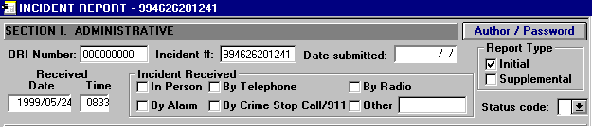
1

- ORI Number. Organization Reporting Identification Number. Leave as is.

- Incident Number. A 12 character (alpha/numeric) number is assigned to each Incident Report to uniquely identify it. The Incident Number shall begin with the last two digits of the year followed by the five digit Unit Identification Code (UIC) or Reporting Unit Code (RUC) of the Installation Security Department or Provost Marshal Office followed by the five digit sequential number.

  - Example: “994626201241" (“99"=year, ”46262"=UIC and “01241" 1,241st report of the year).

- Report Submitted. Enter the Year, Month, Day (YYYY/MM/DD) the report is written. This date is to be filled in when the report is completed and ready for printing. Be sure you are done with the report before entering the date in this field, as once a date is entered, no more changes/editing will be allowed.

- Report Type. Check the appropriate block to indicate the type of report being submitted.

  - Authorized entries: (select one)

    - Initial Report - Self-explanatory.
    - Supplemental - Select if report being submitted is to add and/or change information to a previously submitted report. The Incident Number will remain the same as the Incident Number assigned to the Initial Report.

- Date Received. Enter the Year, Month, Day (YYYY/MM/DD) the incident was first brought to the attention of the military police.

  - Example: If the incident was reported to the military police on July 04, 1994, the entry should be "1994/07/04".

- Time Received. Enter the local military time the report was received by the Security Department.

  - Example: Format for time is HHMM “1330".

- Incident Received. Check the appropriate block designating how the incident was received by the Security Department/Provost Marshals Office, not how the individual patrolman/MP was notified of the incident.

    - Authorized entries: (select one).

      - In Person - Walk-ins to MP/Security Desk, PMO, NCIS or CID
      - By Telephone - Telephone located at Security Department, PMO, NCIS or CID
      - By Radio - Patrolman or MP on patrol reports incident to Security Department/PMO Dispatcher.
      - By Alarm - Self-explanatory.
      - By Crime Stop Call/911 - Self-explanatory.
      - Other - Message, Letter, Computer, E-mail, CB, etc.

- Status. Select the appropriate entry to indicate the status of the report. Initial reports will always be “0” until reviewed and approved by watch supervisor.

  - Authorized entries: (select one)

    - ? - Ready for review by author
    - 0 – Assigned to officer
    - 1 – Corrections made
    - 2 – Reviewed and approved by watch supervisor
    - 3 – Initial review completed by Investigations Div.
    - 4 – Initial Administrative Division processing
    - 5 – Assigned for further investigation
    - 6 – Reviewed and approved by supervisory
    - 7 – Final smooth printing by administrative
    - 8 – Routed for all appropriate signature
    - 9 – Completed final smooth in administration
    - A – Report of Action requested
    - B – Report of Action received
    - C – Report of Action mailed to command
    - D – Completed case filed

SECTION II – COMPLAINANT

This section is used for the recording of information describing the complainant for an incident/offense only when the complainant is not the victim or witness. If there is no complainant, leave section blank.

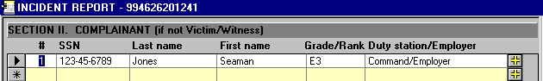
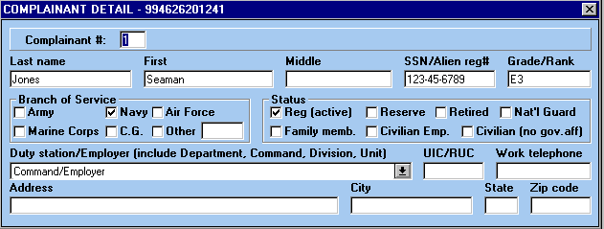

- Last Name, First, Middle. Enter individuals full name. If no middle name enter “NMN” or if initial only, enter the initial in quotation marks, i.e., “L.” Include Jr., Sr., II, III, etc.

- SSN/Alien Registration Number. Enter the individual’s social security number. In the case of foreign nationals, the employee’s service number or host country identification number is to be entered. If individual does not have a SSN or other identifying number, leave blank.

- Grade/Rank. For military personnel (including foreign military members) enter the individual’s rank or grade (not MOS, Navy rating, or job specialty). For government civilian employees enter the individual’s paygrade, i.e., GS-12, GM-13, WG-7, etc. If the individual’s status is a civilian with no government affiliation, military retiree or foreign national, leave blank.

  - Example 1: The individual in the Navy is a rated GMG2, “E-5" should be entered vice GMG2. If the individual is a Staff Sergeant in the U.S. Air Force, enter “E-5”.

  - Example 2: Individual is a Police Officer for Department of the Navy, if the individual is a “GS-5" that is what should be entered.

- Branch of Service. Select the individual’s branch of service. If the individual is a service member from a foreign country, select Other and enter the individual’s branch of service as reflected on passport or identification card, if available. If individual has no service affiliation leave blank.

  - Authorized entries: (select one)

    - Army - U.S. Army
    - Navy - U.S. Navy.
    - Air Force - U.S. Air Force
    - Marine Corps - U.S. Marine Corps
    - Coast Guard - U.S. Coast Guard
    - Other: - National Guard, RN - British Royal Navy, RAF - British Royal Air Force, SARAF - Saudi Arabian Royal Air Force, etc.

- Status. Select the individual’s personnel status. Complete this section for all individuals.

  - Authorized entries: (select one)

    - Regular (Active) - Military service member. Self-explanatory.
    - Reserve - Military service member. Self-explanatory.
    - Retired - Military service members only. Self-explanatory.
    - National Guard - Self - explanatory.
    - Family Member - Military service member, i.e., Spouse, Son, Daughter, etc.
    - Civilian Employee - Individual employed by the U.S. Government.
    - Civilian - No government affiliation or foreign nationals.

- Duty Station/Employer (include Department/Command/Division/ Unit, etc). Enter the name of the individual’s duty station or employer, including department/command/ division/unit, etc., if active duty military or government employee. If the individual is TAD/TDY from his/her permanent duty station, enter their permanent duty station in this block. If the individual is not active duty or a government employee, enter the individual’s current employer, i.e., McDonalds Restaurant. If unemployed or employer unknown, leave blank.

  - Example: If the individual is permanently assigned to the USS George Washington (CVN-73) TAD to Naval Station Norfolk for training, “USS GEORGE WASHINGTON (CVN-73)/Air Department/V-1 Division” will be entered in this block.

- UIC/RUC (Unit Identification Code/Reporting Unit Code). If active duty military or government employee, enter the individual’s permanent duty station unit’s identification code. If the individual does not have a UIC/RUC leave blank, i.e., civilian with no affiliation to the government.

- Work Phone. Enter the individual’s work phone number. If unknown, leave blank.

- Address. Enter the individual’s (military) duty station address or (civilians) home address. If unknown, leave blank.

- City. Self-explanatory. If unknown, leave blank.

- State. Self-explanatory. If unknown, leave blank.

- Zip Code. Self-explanatory. If unknown, leave blank.

SECTION III – OFFENSE

This section is used for the recording of information describing each offense committed in an incident and/or complaint.

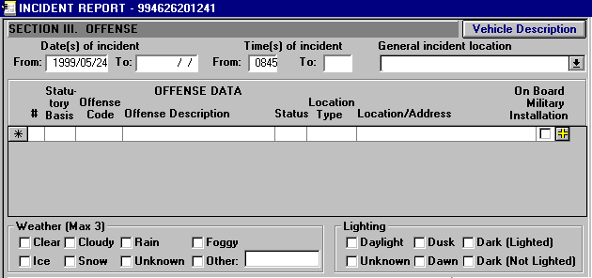

- Date(s) of Incident. Enter the Year, Month, Day (YYYY/MM/DD) when the incident occurred or started, or the beginning of the time period in which it occurred (as appropriate). If the "Incident Date" is unknown, enter the approximate date the incident occurred.

  - Example (1): If a robbery occurred on July 2, 1989, the entry should be "1989/07/02".

  - Example (2): If a kidnapping started on November 1, 1989, and ended on November 16, 1989, the entry should be From: "1989/11/01" To: “1989/11/16".

- Time of Incident. Enter the time (24-hour clock) when the incident occurred or started, or the beginning of the time period in which it occurred (as appropriate). If the "Time of Incident" is unknown, enter the approximate time the incident occurred.

  - Example (1): If a robbery occurred at 9:00 a.m., the entry should be "0900."

  - Example (2): If the time of the incident is unknown, but the time of the incident was between 10:00 a.m. and 1:00 p.m., the entry should be From: ''1000" To: “1300''.

- General Incident Location: Select the installation where incident occurred from the current list. If incident occurred off of the installation select “999 Off-Base”.

  - Current authorized entries: (select one)

    - 001 – NAVSTA San Diego
    - 002 – NAS North Island
    - 003 – SUBASE San Diego
    - 004 – NAB Coronado
    - 005 – NOLF Imperial Beach
    - 006 – SPAWAR SYSCEN PL
    - 007 – Fleet ASW Training Center
    - 008 – MWS Seal Beach
    - 009 – NAF El Centro
    - 010 – NAS Lemoore
    - 011 – NWS Concord
    - 012 – NWS Fallbrook
    - 013 – CBC Port Hueneme
    - 014 – NAS China Lake
    - 015 – NAS Fallon
    - 016 – NAS Point Magu
    - 017 – SPAWAR SYSCEN OTC
    - 018 – NALF San Clemente
    - 999 – Off-Base

- Statutory Basis. Enter the code that describes the legal statutory basis for the offense an individual is suspected of committing. In situations where more than one statutory basis may apply, select the statutory basis with jurisdiction over the offense.

  - Authorized entries: (enter only one)

    - U - UCMJ - Uniform Code of Military Justice
    - F - Federal - Federal U.S. Code.
    - S - State - State Laws, i.e., Traffic Laws, etc.
    - L - Local - Local Laws, i.e., Traffic Laws, Curfew Violations, etc.
    - F - Foreign - Foreign Laws, i.e., violations of Status of Forces Agreement, Customs Violations, etc.

  - Example: If the suspect is suspected of Unauthorized Absence, “U” should be entered as no other agency provides a statutory basis for this offense.

- Offense Code/Description. Offense blocks are used to identify and describe the types of offenses involved in the incident (e.g., Arson, Prostitution, etc.). Select the appropriate type crime from the Offense Code. ALWAYS enter the MOST SEVERE OFFENSE FIRST. Care should be used to identify all of the offenses involved in a particular criminal incident. Generally "Traffic Offenses" are excluded from this offense category. The vehicle related offenses of "Hit and Run," (of a person) and "Vehicular Manslaughter" are, however, included; but "Driving Under the Influence" is not as it is a separate offense.

  - Example (1): In the same incident, the Suspect/ Arrestee assaulted two persons by threatening them with a handgun. Only one Offense block should be identified as Aggravated Assault.

  - Example (2): Care must also be take to ensure that each offense which is reported is a separate, distinct crime and not just a part (element) of another offense. For example, every robbery includes some type of assault; but, because the assault is an element of the crime of Robbery, only “Robbery” is reported. However, if during a robbery the victim was forced to engage in sexual relations, both “Robbery” and “Forcible Rape” are reported, as forced sexual intercourse is not an element of the crime of Robbery.

- Offense Status. Used to indicate whether each offense in the incident was completed or merely attempted. If there was more than one occurrence of the same offense within an incident and one was completed, then "Completed" will be selected. Enter only one per offense.

  - It should be noted that "Attempted Murder" is to be reported as Aggravated Assault, and all Assault Offenses should be marked as "Completed."

  - Example: During the same incident, Suspect/Arrestee 1 raped Victim 1 and Suspect/Arrestee 2 attempted to rape Victim 2, but left the scene before the act was consummated. Since one rape was completed, “Completed” should be selected for offense 1 “Forcible Rape”.

- Location Type and Location/Address. Select the appropriate location type of the incident. The location/address can be changed to reflect a specific location/address (i.e. bldg. number, street address, etc.).

- On Board Military Installation. Select if the incident occurred while on government owned/leased property, i.e., base, station, leased government building, military aircraft, or military ship, select box, otherwise leave blank.

    - Example (1): A burglary takes place in base housing located on government leased property, box should be selected.

    - Example (2): An individual is arrested by civilian authorities for reckless driving while operating a government-owned pick-up truck in downtown San Diego. Since this incident did not take place on a government installation, leave box blank.

- Weather Conditions. Select the weather conditions at the time of the offense. If the weather conditions are unknown at the time of the offense, select Unknown.

  - Authorized entries: (select most applicable)

    - Clear - sunny, clear sky.
    - Cloudy - include partly cloudy skies.
    - Rain - self-explanatory.
    - Foggy - smoky.
    - Ice - self-explanatory.
    - Snow - self-explanatory.
    - Unknown - self-explanatory.
    - Other - sleet, hail, etc.

  - Example: If the weather at the time the offense took place was rainy and foggy, both “Rain” and “Foggy” should be selected.

- Lighting. Select the lighting conditions at the time the offense took place. If lighting conditions are not known at the time of the offense, select Unknown.

  - Authorized entries: (select only one)

    - Daylight - self-explanatory
    - Dusk - time between daylight and dark.
    - Dawn - time between dark and daylight.
    - Dark (Lighted) - use of artificial light, street light, etc.
    - Dark (Not Lighted) - self-explanatory
    - Unknown - self-explanatory

SECTION III – OFFENSE (cont’d)

Offense Detail

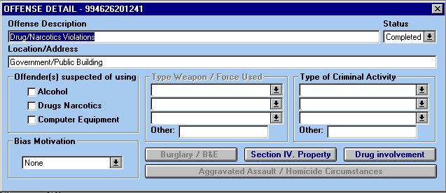

- Offender(s) Used. Indicate whether any of the offenders in the incident were suspected of consuming alcohol or using drugs/ narcotics during or shortly before the incident; or of using a computer, computer terminal, or other computer equipment to perpetrate the crime.

  - Up to three (3) entries can be made.

  - Authorized entries: (enter up to 3)

    - Alcohol
    - Computer Equipment.
    - Drugs/Narcotics

  - Example (1): Witnesses to an assault reported that the victim and offender were in a bar drinking beer when an argument broke out and the offender attacked the victim with a knife. “Alcohol” should be selected.

  - Example (2): A rape victim advised that her attacker bragged that he had been "free basing" cocaine just prior to the incident. “Drugs/Narcotics” should be selected.

  - Example (3): A medical supply warehouse was burglarized and large quantities of Methadone, Morphine, Benzedrine, and Valium were stolen. “Drugs/Narcotics” should not be entered because, while the drugs were the object of the crime, there was no indication that the offenders used drugs or narcotics before or during the incident.

  - Example (4): A computer "hacker" used his personal computer and a telephone modem to gain access to a company's computer and steal proprietary data. “Computer Equipment” should be selected.

  - Example (5): A private residence was burglarized and a personal computer was stolen, along with other items. “Computer Equipment” should not be entered because, while the computer was one of the fruits of the crime, it was not used to commit the crime.

- Bias Motivation. If an offense being reported is the result of expressed hate or bias due to the victim’s race, sexual orientation, religion or ethnicity, the appropriate box indicating the type of bias or hate should be selected. The incident must have occurred as a result of hate or bias. If the incident was not a result of hate or bias motivation “NONE” should be marked.

  - All offenses considered to be a result of hate or bias will be reported to the Naval Criminal Investigative Service (NCIS).

  - Authorized Entries:

    - Anti-White
    - Anti-Black
    - Anti-Arab
    - Anti-Hispanic
    - Anti-American Indian
    - Anti-Alaskan Native
    - Anti-Asian
    - Anti-Pacific Islander
    - Anti-Other
    - Anti-Multi-Racial Group
    - Anti-Jewish
    - Anti-Catholic
    - Anti-Islamic (Muslim)
    - Anti-Protestant
    - Anti-Other Religion
    - Anti-Multi-Religious
    - Anti-Other Religion
    - Anti-Atheism
    - Anti-Agnostic
    - Anti-Homosexual
    - Anti-Male Homosexual
    - Anti-Female Homosexual
    - Anti-Heterosexual
    - Anti-Bisexual

  - Example: If a white male assaults a black male because of a dispute over a parking place, there in no hate or bias crime, even if the white male harbors a hatred for black people. If, however, the white male assaulted the black male solely because of his hatred or bias (not as a result of the parking space dispute) then a hate or bias crime has been committed and the “Anti-Black” block should be selected.

- Type Weapon/Force Used. Check the box listing the type(s) of weapon(s) or force used by the offender(s) in committing the crime.

  - Up to three (3) types of weapons/force can be entered for each of the offenses.

  - Authorized entries:

    - Firearm (not listed) – manual
    - Firearm (not listed) – semi-automatic
    - Firearm (not listed) - automatic
    - Handgun – manual
    - Handgun – semi-automatic
    - Handgun - automatic
    - Rifle – manual
    - Rifle – semi-automatic
    - Rifle – automatic
    - Shotgun – manual
    - Shotgun – semi-automatic
    - Shotgun - automatic
    - Other Firearm – manual
    - Other Firearm – semi-automatic
    - Other Firearm - automatic
    - Knife/Cutting Instrument (e.g., ax, ice pick, screwdriver, switchblade, etc.)
    - Blunt Object (e.g., club, hammer, etc.)
    - Motor Vehicle (when used as a weapon)
    - Bodily Force (i.e., hands, feet, teeth, etc.)
    - Poison (includes gas)
    - Explosives
    - Fire/Incendiary Device
    - Drugs/Narcotics/Sleeping Pills
    - Asphyxiation
    - Other
    - Unknown
    - None

  - Example (1): Three robbers held up a bank. One was armed with a revolver, the second had a sawed-off shotgun, and the third had an automatic machine gun. All of the following should be selected: “Handgun”; “Shotgun”; and “Automatic Other Firearm”.

  - Example (2): If a bottle was used in the commission of a murder, select “Blunt Object”, if the victim was beaten; or “Knife/Cutting Tool”, if the victim was cut or stabbed.

- Type of Criminal Activity. This section is to be used to provide additional information on the criminal activity of the offender(s) in incidents involving certain types of offenses.

  - Offense types:

    - Counterfeiting/ Forgery
    - Stolen Property Offenses
    - Drugs/Narcotics Violations
    - Drug Equipment Violations
    - Gambling Equipment Violations
    - Pornography/Obscene Material
    - Weapon Law Violations

  - Up to three types of activity can be entered for each of the offenses listed above.

  - Authorized entries:

    - Buying/Receiving
    - Cultivating/Manufacturing/Publishing (i.e., production of any type)
    - Distributing/Selling
    - Exploiting Children
    - Operating/Promoting/Assisting
    - Possessing/Concealing
    - Transporting/Transmitting/Importing
    - Using/Consuming
    - Destruction/Vandalism
    - Harassment/Stalking
    - Other: (Specify)

  - Example: The offenders published and sold pornographic photographs of children. Because up to three types of activity can be entered, “Cultivating/Manufacturing/Publishing”, “Distributing/Selling”, and “Exploiting Children” should be selected.

SECTION III – OFFENSE (cont’d)

Burglary/B&E Detail

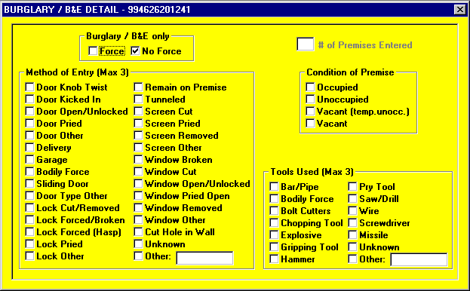

- Burglary/B&E Only

  - Method of Entry - Complete this section only if the offense is Burglary/B&E. It is for reporting whether "Force" or "No Force" was used by the burglar(s) to enter the structure. Check only one entry.

  - Authorized entries: (enter only one)

    - Force - A forced entry is where force of any degree, or a mechanical contrivance of any kind (including a passkey or skeleton key), was used to unlawfully enter a building or other structure.
    - No Force - An unforced entry is one where the unlawful entry was achieved without force through an unlocked door or window.

NOTE: If both forced and unforced entries were involved in the crime, the entry should be reported as having been accomplished through "Force."

  - Example: Investigation of a burglary complaint disclosed that the offender(s) entered the building through an unlocked street door and then forced a locked door to an office and stole a typewriter. since one door was forced, “Force” should be entered.

- Number of Premises Entered. This block is to be used only if the crime is Burglary/B&E and the "Hotel Rule" is applicable. In such cases, the number of structures (premises) entered is to be reported.

  - Hotel Rule is applied to only temporary lodgings. It states: If a number of dwelling units under a single manager are burglarized and the offenses are most likely to be reported to the police by the manager rather than the individual tenants, the burglary should be scored as one offense.

  - Hotel Rule has been expanded to include rental storage facilities, i.e., "Mini-Storage" and "Self-Storage" buildings. Therefore, this data element is to be used if the offense is Burglary/B&E and either BOQ/CBQ/Lodge/Hotel. or Rental Storage Facility is entered into Location of Offense. The total number (up to 99) of individual rooms, units, suites, storage compartments, etc., entered is to be reported in this section.

  - Example (1): A "Self-Storage" building was burglarized and 11 rented storage compartments were forcibly entered. The owner/manager of the building reported the incident to the police. Burglary/B&E should be entered into Offense Description and Rental/Storage Facility should be entered into Location of Offense and the number "11" (for 11 compartments) should be entered into Number of Premises Entered.

  - Example (2): A private residence was burglarized. Burglary/B&E should be entered into Offense Description and Quarters/Barracks/Berthing/Residence/Home should be entered into
- Location of Offense. However, because the "Location of Offense" was not BOQ/BEQ/Navy Lodge/Hotel or Rental/Storage Facility, no entry should be made into Number of Premises Entered. It should be left blank.

- Method of Entry. Select the method of entry used to gain access to the premises. Up to three methods of entry may be selected.

- Condition of Premise. Enter the occupancy status of the premises.

  - Authorized entries: (select only one)

    - Occupied - premises rented, mortgaged, assigned barracks rooms, etc., and person was physically occupying the structure when the incident occurred.
    - Unoccupied - premises rented, mortgaged, assigned barracks rooms, etc., but no person was physically occupying the structure when the incident occurred.
    - Vacant (Temp. Unoccupied) - premises for sale, vacant hotel rooms, unassigned barracks rooms, rental/storage facility, etc.
    - Vacant - premises that do not qualify as one of the above.

- Tools Used. Select the suspected tools used to gain access to a premises.

  - Authorized entries: (select up to 3)

    - Bar/Pipe - self-explanatory
    - Bodily Force - foot, fist, any part of the body
    - Bolt Cutters - self-explanatory
    - Chopping Tool - ax, hatchet, machete, etc.
    - Explosive - Dynamite, home made bomb, etc.
    - Gripping Tool - pipe wrench, pliers, etc.
    - Hammer - Claw hammer, sledge hammer, etc.
    - Pry Bar - crow bar, etc.
    - Saw/Drill - circular saw, hack saw, hand drill, electric drill, etc.
    - Wire - coat hanger, etc.
    - Screwdriver - self-explanatory
    - Missile - rock, brick, anything thrown to gain access to premises.
    - Unknown - self-explanatory
    - Other - slim jim, lock picks, glass cutter, file, etc.

  - Example: Small metal filings are observed on the floor below a broken padlock to a storage facility, the lock appears to have been cut with a hack saw, the “Saw/Drill” box should be selected.

SECTION III – OFFENSE (cont’d)

Suspected Drug Involvement/Drugs Seized

Complete these blocks only if one of the offenses in an incident was Drug/Narcotic Violations, "6" = Seized was entered into type Property Loss/Etc., and "10" = Drugs/Narcotics was entered into Property Description Code. Do not complete when drugs or narcotics were burned, stolen, etc., in connection with other offenses, such as Arson, Burglary/B&E, Larceny/Theft, etc.

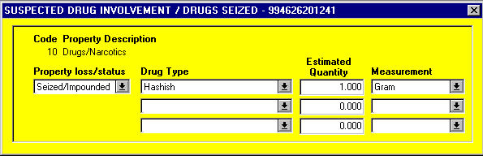

- Drug Type. Enter the suspected types of drugs or narcotics that were seized in a drug case. Therefore, it is used only if one of the offenses in the incident was Drug/Narcotic

  - Up to three types of drugs/narcotics can be entered. If more than three are involved, the two most important (as determined by the reporting agency taking into account the quantity, value, and toxicity of the drugs/narcotics) are to be reported under their applicable drug types and the remaining drugs/narcotics are to be entered as a single "X" = Over 3 Drug Types entry.

  - Violations, "6" = Seized was entered into Type Property Loss/Etc., and "10" = Drugs/Narcotics was entered into Property Description Code.

  - Authorized entries: (enter up to 3)

    - "Crack" Cocaine
    - Cocaine - (all forms except “Crack")
    - Hashish
    - Heroin
    - Marijuana
    - Morphine
    - Opium
    - Other Narcotics - Codeine; Demerol; Dihydromorphinone or Dilaudid; Hydrocodone or Percodan; Methadone; etc.
    - LSD
    - PCP
    - Other Hallucinogens - BMDA or "White Acid"; DMT; MDA; MDMA; Mescaline or Peyote; Psilocybin; STP; etc.
    - Amphetamines/Methamphetamine
    - Other Stimulants - Adipex, Fastine, and Ionamin (Derivatives of Phentermine); Benzedrine; Didrex; Methylphenidate or Ritalin; Phenmetrazine or Preludin; Tenuate; etc.
    - Barbiturates
    - Other Depressants - Glutethimide or Doriden; Methaqualone or Quaalude; Pentazocine or Talwin; etc.
    - Other Drugs - Antidepressants (Elavil, Triavil, Tofranil, etc.); Aromatic Hydrocarbons; Propoxyphene or Darvon; Tranquilizers (Chlordiazepoxide or Librium, Diazepam or Valium, etc.); etc.
    - Unknown Type Drug
    - Over 3 Drug Types

  - Example: In a drug case, the following drugs were seized:

    - 1.5 kilograms of "Crack"
    - 2.125 pounds of Marijuana
    - 2.0 liquid ounces of Morphine
    - 500 Valium capsules.
    - The "Crack" was entered as "A" and the Marijuana as "E". The Morphine and Valium were coded as a single "X"-entry because more than three types of drugs were seized.

- Estimated Drug Quantity. Used to indicate the quantity of drugs or narcotics seized in a drug case.

  - Enter the number of whole pounds, ounces, grams, etc., and three (3) more characters are available to enter the decimal amount. A decimal point must be entered to separate the whole and decimal amounts.

  - Example: In the example given above, the entries should be "1.5" for the "Crack" and "2.125" for the Marijuana. No "quantity" entries should be made for the Morphine or Valium.

- Measurement. Enter the type of measurement used in quantifying drugs or narcotics seized in a drug case.

  - Authorized entries: (enter up to 3) WEIGHT CAPACITY UNITS.

    - Gram
    - Kilogram
    - Ounce
    - Pound
    - Milliliter
    - Liter
    - Gallon
    - Fluid Ounce
    - Dosage Units/Items*
    - Number of Plants**
    - Not Reported

*Number of capsules, pills, tablets, etc.

**E.g., Marijuana plants (bushes), etc.

  - Example: In the example give above, the entries should be "KG" for the "Crack" and "LB" for the Marijuana. No entries should be made for the Morphine or Valium.

SECTION III – OFFENSE (cont’d)

Aggravated Assault/Homicide Circumstances

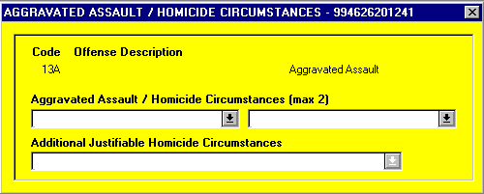

- Aggravated Assault Circumstances. Select the appropriate box(es) that describes the circumstances of either an aggravated assault or a homicide. Complete this box only if an Aggravated Assault.

  - Authorized entries: (enter up to 2)

    - Argument
    - Assault on Law Enforcement Officer(s)
    - Drug Dealing
    - Gangland
    - Juvenile Gang
    - Lovers' Quarrel/Domestic
    - Other Felony Involved
    - Other Circumstances
    - Unknown Circumstances

  - Example: Two rival juvenile street gangs rumble over "turf" rights to sell drugs and one of the gang members was beaten and stabbed with a knife. Possible selections are “Argument”, “Drug Dealing”, and “Juvenile Gang”. While all three would apply, there is a limit of two entries. Therefore, the two most descriptive codes should be used. In this case, “Drug Dealing” and “Juvenile Gang”.

- Additional Justifiable Homicide Circumstances. Not normally used by initial reporting officer.

  - Authorized Entries:

    - Criminal Attacked Police Officer and That Officer Killed Criminal
    - Criminal Attacked Police Officer and Criminal Killed by Another Police Officer
    - Criminal Attacked a Civilian
    - Criminal Attempted Flight From a Crime
    - Criminal Killed in Commission of a Crime
    - Criminal Resisted Arrest
    - Unable to Determine/Not Enough Information

SECTION IV – Property

The Property Section is used for the recording of information describing property that is lost, stolen, recovered, seized, etc. as a result of an incident. Property information should be submitted only for crimes against property and/or Kidnapping/Abduction.

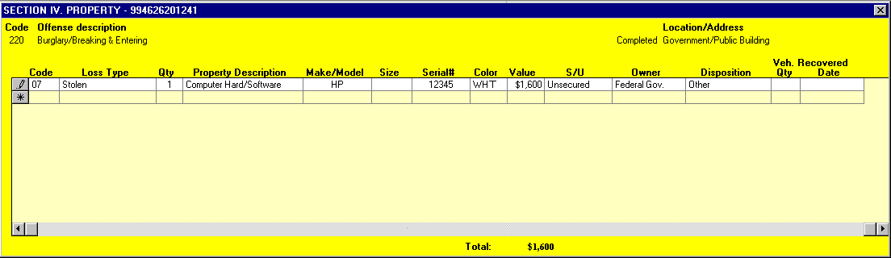

- Property. The Property Section can only be filled out for the following types of crimes:

  - Kidnaping/Abduction
  - Robbery
  - Arson
  - Extortion/Blackmail
  - Burglary/B&E
  - Pocket-Picking
  - Purse-Snatching
  - Shoplifting
  - Theft From Building
  - Theft From Coin-Operated Machine or Device
  - Theft From Motor Vehicle
  - Theft of Motor Vehicle Parts or Accessories
  - All Other Larceny
  - Motor Vehicle Theft
  - Counterfeiting/Forgery
  - False Pretenses/Swindle/Confidence Game
  - Credit Card/Automatic Teller Machine Fraud
  - Impersonation
  - Welfare Fraud
  - Wire Fraud
  - Embezzlement
  - Stolen Property Offenses (Receiving, etc.)
  - Destruction/Damage/Vandalism of Property
  - Drug/Narcotic Violations.
  - Drug Equipment Violations
  - Betting/Wagering
  - Operating/Promoting/Assisting Gambling
  - Gambling Equipment Violations
  - Sports Tampering
  - Bribery

- Property Description Code. Used to enter descriptions of the property which was burned, counterfeited, destroyed/damaged/ vandalized, etc., as a result of the incident.

  - Up to ten items of property may be entered into the Property Section. Property descriptions codes can be entered for each Property Section (i.e., each type of property loss/etc.) involved in the incident.

  - If more than ten types of property are involved, the nine most valuable specifically coded types of property are to be entered and the remaining types of property are to be combined and entered as "77" = Other.

  - Authorized entries: (enter up to 10 per Property Section)

    - 01 = Aircraft (airplanes, dirigibles, gliders, etc.)
    - 02 = Alcohol (alcoholic beverages, e.g., beer, wine, liquor, etc.)
    - 03 = Automobiles (sedans, coupes, station wagons, convertibles, taxicabs, and other similar motor vehicles which serve the primary purpose of transporting people)
    - 04 = Bicycles (includes tandem bicycles, unicycles, and tricycles)
    - 05 = Buses (motor vehicles which are specifically designed, but not necessarily used, to transport groups of people on a commercial basis)
    - 06 = Clothes/Furs (wearing apparel for human use, including accessories such as belts, shoes, scarves, ties, etc.)
    - 07 = Computer Hardware/Software (computers, computer peripherals [e.g., tape and disk drives, printers, etc.], and storage media [e.g., magnetic tapes, magnetic and optical disks, etc.])
    - 08 = Consumable Goods (expendable items used by humans for nutrition, enjoyment, or hygiene, e.g., food, beverages, grooming products, cigarettes, gasoline, firewood, etc.)
    - 09 = Credit/Debit Cards (includes Automatic Teller Machine cards)
    - 10 = Drugs/Narcotics
    - 11 = Drug/Narcotic Equipment
    - 12 = Farm Equipment (tractors, combines, etc.)
    - 13 = Firearms (weapons that fire a shot by force of an explosion, i.e., handguns, rifles, shotguns, etc., but not "BB," pellet, or gas-powered guns)
    - 14 = Gambling Equipment (gambling paraphernalia)
    - 15 = Heavy Construction/Industrial Equipment (cranes, bulldozers, steamrollers, oil-drilling rigs, etc.)
    - 16 = Household Goods (beds, chairs, desks, sofas, tables, refrigerators, stoves, washer/dryers, air conditioning and heating equipment, etc.)
    - 17 = Jewelry/Precious Metals (bracelets, necklaces, rings, watches, etc., and gold, silver, platinum, etc.)
    - 18 = Livestock (living farm-type animals, e.g., cattle, chickens, hogs, horses, sheep, etc., but not household pets, such as dogs and cats)
    - 19 = Merchandise (items held for sale)
    - 20 = Money (legal tender, i.e., coins and paper currency)
    - 21 = Negotiable Instruments (any document, other than currency, which is payable without restriction, e.g., endorsed checks, endorsed money orders, and endorsed traveler's checks; "bearer" checks and bonds; etc.)
    - 22 = Nonnegotiable Instruments (documents requiring further action to become negotiable, e.g., unendorsed checks, unendorsed money orders, etc.; food stamps; stocks and bonds; etc.)
    - 23 = Office-type Equipment (typewriters, adding machines, calculators, cash registers, copying machines, etc.) For Computer Equipment, refer to code “07".
    - 24 = Other Motor Vehicles (any other motor vehicles, e.g., motorcycles, motor scooters, trail bikes, mopeds, snowmobiles, golf carts, etc.)
    - 25 = Purses/Handbags/Wallets
    - 26 = Radios/TVS/VCRs (includes radios, televisions, videotape recorders, high fidelity and stereo equipment, compact disk players, etc.)
    - 27 = Recordings-Audio/Visual (phonograph records, compact disks, tape recordings, cassettes, etc.)
    - 28 = Recreational Vehicles (motor vehicles which are specifically designed, but not necessarily used, to transport people and also provide them temporary lodging for recreational purposes)
    - 29 = Structures-Single Occupancy Dwellings (houses, townhouses, duplexes, mobile homes, or other private dwellings which are occupied by a single person, family, house mates, or other group)
    - 30 = Structures-Other Dwellings (any other residential dwellings not meeting the definition of "Single Occupancy Dwellings," e.g., apartments, tenements, flats, boarding houses, dormitories, as well as temporary living quarters, such as hotels, motels, inns, etc.)
    - 31 = Structures-Other Commercial/Business (stores, office buildings, restaurants, etc.)
    - 32 = Structures-Industrial/Manufacturing (factories, plants, assembly lines, etc.)
    - 33 = Structures-Public/Community (colleges, hospitals, jails, libraries, meeting halls, passenger terminals, religious buildings, schools, sports arenas, etc.)
    - 34 = Structures-Storage (barns, garages, storehouses, warehouses, etc.)
    - 35 = Structures-Other (any other structures not fitting the other "Structures" descriptions, e.g., outbuildings, monuments, buildings under construction, etc.)
    - 36 = Tools (hand tools and power tools)
    - 37 = Trucks (motor vehicles which are specifically designed, but not necessarily used, to transport cargo on a commercial basis)
    - 38 = Vehicle Parts/Accessories (motor vehicle batteries, engines, transmissions, heaters, hubcaps, tires, manufacturers' emblems, license plates, side view mirrors, radios, antennas, tape decks, etc.)
    - 39 = Watercraft (motorboats, sailboats, houseboats, etc.)
    - 77 = Other (all other property not fitting the above specific descriptions, including intangibles).
    - 88 = Pending Inventory (property description unknown until an inventory is conducted)
    - 99 = Special Category to be used by the National UCR Program to compile statistics on certain designated types of property, e.g., "CB" radios, which are the object of theft fads)

  - Example (1): The following property was stolen as the result of a burglary:

    - a $10,000 stamp collection
    - jewelry worth $5,000
    - an $1,800 personal computer
    - clothes worth $1,500
    - silverware worth $800
    - a $650 TV
    - a $450 VCR
    - a $400 microwave oven
    - $350 in cash
    - a $250 typewriter
    - a $150 shotgun
    - a $100 bicycle
    - two credit cards (no value)
    - ten blank personal checks (no value).

  - Item (1), the stamp collection, was the most expensive property, however, because it does not fit into any of the specifically coded property descriptions, it should be included in "77" = Other. Items (2) through (12) then become the nine most valuable coded properties as follows:

    - the jewelry and silverware should be entered as code "17"
    - the personal computer as "07"
    - the clothes as "06"
    - the TV and VCR as "26"
    - the microwave oven as "16"
    - the cash as "20"
    - the typewriter as "23"
    - the shotgun as "13"
    - and the bicycle as "04"
    - Items (13) and (14), i.e., the two credit cards and ten blank bank checks, should be combined with Item (1), the stamp collection, and entered as "77".

  - Example (2): If a house was destroyed by arson and the homeowners are away on an overseas trip making it impossible to determine the property loss until they return, enter "88" = Pending Inventory.

Note: An updated Property Section with entries describing the type(s) of burned property should be submitted when the results of the inventory are subsequently learned.

- Type Property Loss/Etc. This section is to be used to describe the type(s) of property loss, recovery, seizure, etc., which occurred in an incident.

  - Authorized entries: (enter one per Property Section)

    - 1 = None
    - 2 = Burned (includes damage caused in fighting the fire)
    - 3 = Counterfeited/Forged
    - 4 = Destroyed/Damaged/Vandalized
    - 5 = Recovered (to impound property which was previously stolen)
    - 6 = Seized/Impound (to impound property which was not previously stolen)
    - 7 = Stolen (includes bribed, defrauded, embezzled, extorted, ransomed, robbed, etc.)
    - 8 = Unknown
    - 9 = Lost& Found - includes property which was turned in as lost & found.

  - Example (1): For Arson, the entries might be:

    - “1" = None (an attempt with no property burned)
    - “2" = Burned (property burned)
    - “8" = Unknown (not known whether property burned).

  - Example (2): For Burglary, the entries might be:

    - "1" = None (an attempted burglary, or the structure was entered but no property was taken)
    - "7" = Stolen (property was taken)
    - "5" = Recovered (stolen property was recovered)
    - "8" = Unknown (it is not known whether property was taken).

  - Example (3): If the same incident involved both Arson and Burglary, the choices of property loss/etc. Codes shown in Examples (1) and (2) would be applicable, depending on the circumstances.

- Quantity (QTY). Self-explanatory.

  - If several items of property have the same description they may be listed on the same property line. The quantity of these similar items should be entered. If unknown, leave blank.

  - Example: Two victims had their bicycles stolen at the same time and place - one was worth $300 and the other $150. "04" = Bicycles should be entered into Property Description Code, “7" = Stolen is entered in to the Type Code and their total value "450" ($300 + $150 = $450) into Value.

- Description. Enter a brief description of item.

  - Example: Computer, Video Camera, Wedding Ring, Dining Table, etc.

- Make/Model. List the make/model of the item.

  - Example: IBM Select III, Canon AE-1, Seiko, Motorola, etc.

- Size. Enter the approximate size of item.

  - Example: Ring - “10", Shoe - “12D”, Clothing - “Small”, etc.

- Serial #. Self-explanatory. If unknown, leave blank.

- Color. Enter the most predominant color. If unknown, leave blank.

- Value. Used to enter the total dollar values of the property which was burned (includes damage caused in fighting the fire), counterfeited, destroyed/damaged/vandalized, recovered, seized, stolen, etc., as a result of the incident.

  - The value should be reported in whole dollars.

  - The value entered for each property description should be the total value of the property loss/etc., for all of the victims in the incident.

  - If the value is unknown, enter one dollar ($1.00) which means unknown, i.e., "1" = Unknown.

  - If drugs or narcotics were seized in a drug case, no value is to be entered, but the estimated quantity of the drugs/narcotics is to be reported. Therefore, when the offense is Drug/Narcotic Violations, "6" = Seized/Impounded was entered into Type of Loss, Etc., and "10" = Drugs/Narcotics was entered into Property Description Code, no value is to be entered the Drug Type, Est. Quantity, and Measurement are to be used instead.

  - However, when drugs or narcotics are involved in other types of crime (e.g., they were stolen through burglary, robbery, theft, etc., or destroyed by arson) their value is to be entered and Drug Type, Est. Quantity, and Measurement are to be left blank.

  - Example (1): In Example (1) given under the Property Description Code above, the values for each specifically coded property should be entered as follows:

    - “5,800" for code "17" (the jewelry and silverware)
    - “1,800" for code "07" (the personal computer)
    - “1,500" for code "06" (the clothes)
    - “1,100" for code "26" (the TV and VCR)
    - “400" for code "16" (the microwave oven)
    - “350" for code "20" (the cash)
    - “250" for code "23" (the typewriter)
    - “150" for code "13" (the shotgun)
    - “100" for code "04" (the bicycle)
    - “10,000" for code "77" (the stamp collection, the two credit cards, and the ten blank checks).

  - Example (2): In Example (1) given for Property Description Code, above, since a determination of the property loss must await an inventory, "1" ($1.00) = Unknown should be entered into Value.

Note: An updated Property Section with appropriate property loss values should be submitted after the results of the inventory are learned.

- Secured/Unsecured. Used to identify if property was secured or unsecured. If unknown, leave blank.

  - Authorized entries: (select only one)

    - S = Secured
    - U = Unsecured

- Owner. Enter the owner of the property code for all property.

  - Authorized entries: (select only one)

    - A = Federal Government
    - B = State Government
    - C = City Government
    - D = County Government
    - E = Foreign Government
    - F = Private or Personnel Owner

  - Example: Property is seized as evidence from a suspect listed as Suspect-02, which belongs to Victim-01, the “F” code should be entered as the property belongs to a private or personal owner.

- Disposition of Property. Used to describe the disposition of the property held by the security department or provost Marshall.

  - Authorized entries: (select only one)

    - E = Evidence - self-explanatory
    - S = Safekeeping - property listed as lost and found
    - R = Return to Owner - property listed as stolen or recovered and not required as evidence.

- Veh Qty. Self-Explanatory.

- Date Recovered. If previously stolen property is recovered, the Month, Day, and Year (YYYY/MM/DD) of its recovery is to be entered into this block. Accordingly, this block is to be used only if "5" - Recovered is entered into Type Property Loss/Etc.). If there is more than one date of recovery for he same Property Description Code, enter the earliest date. If the recovery date is unknown, enter the date of the report.

- Example: On March 28, 1989, three (3) cars were stolen from a used car lot. One of the cars was recovered on July 1, 1989. On July 24, 1989, a second car was recovered. The date entered should be "1989/07/01".

SECTION V – VICTIM

The Victim Section is to be used for the recording of information describing the victim(s) of an offense.

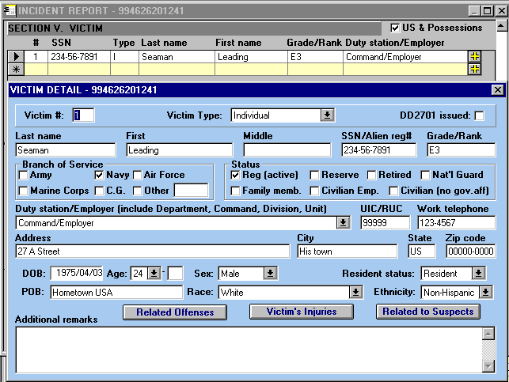

- U.S. & Possessions. Select the location the offense took place in the world.

  - Authorized entries: (select only one)

    - U.S. & Possessions - continental United States, Alaska, Hawaii, Puerto Rico, Guam, U.S. Virgin Islands, etc.
    - Outside U.S. & Possessions - all areas not part of the United States or its possessions, i.e., Europe, South America, Southeast Asia, etc.

  - Example: An assault and larceny take place at Naval Station Pearl Harbor, the “U.S. & Possessions” block should be selected.

- Victim Number (Sequence). Each victim in an incident is to be assigned a sequence number from "001" to "999." A separate "Victim Section" is to be submitted for each numbered victim.

- Type of Victim. Select the appropriate block to indicate the type of victim. Select only one entry per victim.

  - Authorized entries: (enter only one)

    - Individual
    - Business
    - Financial Institution
    - Government
    - Law Enforcement
    - Religious Organization
    - Society/Public
    - Other
    - Unknown

  - Example: During a credit union robbery, the offender pointed a gun at a teller and demanded and received money. The robber also pistol whipped a customer who stood in his way as he made his getaway from the credit union. There were three (3) victims, i.e., the credit union (Financial Institution), the teller (Individual), and the pistol-whipped customer (Individual). Therefore, their codes should be entered into their respective Victim Sections.

- DD 2701 Issued. Select either Yes or No, if the Victim/Witness Assistance Rights Pamphlet (DD Form 2701) is issued to victim.

- Last Name, First, Middle. Refer to Complainant Section.

- SSN/Alien Registration Number. Refer to Complainant Section.

- Grade/Rank. Refer to Complainant Section.

- Branch of Service. Refer to Complainant Section.

- Status. Refer to Complainant Section.

- Duty Station/Employer. Refer to Complainant Section.

- UIC/RUC. Refer to Complainant Section.

- Work Phone. Refer to Complainant Section.

- Address. Refer to Complainant Section.

- City. Refer to Complainant Section.

- State. Refer to Complainant Section.

- Zip Code. Refer to Complainant Section.

- DOB (Date of Birth). If the victim was a person (i.e., “I” = Individual was entered into Type of Victim), enter the individuals date of birth, (Year, Month, Day) (YYYY, MM, DD). If unknown, enter “UNK”.

  - Example: If the victim was born on April 11, 1965, the entry should be “1965/04/11".

- POB (Place of Birth). If the victim was a person (i.e., Individual was selected in the Type of Victim block), enter the victim’s place of birth (City, State or City, Country). If unknown, leave blank.

  - Example 1: If the victim was born in San Antonio, Texas, the entry should be “San Antonio, TX”.

  - Example 2: If the victim was born in Naples, Italy, the entry should be “Naples, Italy”.

- Sex. If the victim was a person (i.e., Individual was select in the Type of Victim block), select the box that indicated the victim’s sex.

  - Authorized entries: (enter only one)

    - Male
    - Female
    - Unknown

- Race. If the victim was a person (i.e., Individual was selected in the Type of victim block), select the box that indicates the victim’s race.

  - Authorized entries: (enter only one)

    - White
    - Black
    - American Indian/Alaskan Native
    - Asian/Pacific Islander
    - Unknown

- Ethnicity. If the victim was a person (i.e., Individual was selected in the Type of Victim block), select the appropriate box that indicates the victim’s ethnic origin.

  - Authorized entries: (enter only one)

    - Hispanic Origin
    - Not of Hispanic Origin
    - Unknown

- Resident Status. If the victim was a person (i.e., Individual was selected in the Type of Victim block), select the appropriate box indicating the victim’s residency status.

  - A "Resident" is a person who maintains his/her permanent home for legal purposes in the locality (i.e., town, city, or community) where the crime took place.

  - Authorized entries: (enter only one)

    - Resident
    - Nonresident
    - Unknown

  - Example (1): If the victim was robbed on Naval Base San Diego, California, where he is assigned to the Admin Department, select “Resident”.

  - Example (2): If the victim was a business (i.e., Business was selected in the Type of Victim block), leave block blank.

SECTION V – VICTIM

Relationship to Offenses

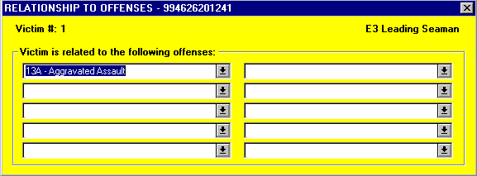

- Victim Related to Offense #. Select the appropriate boxes to indicate specific offense(s) associated with this victim. More than one box may be selected if victim is related to additional offenses. Up to 10 offenses boxes may be selected per victim.

  - Example: Victim 001 is related to Offense No. 1, Aggravated Assault, however not related to Offense No. 2, only box number “1" should be selected. However, if Victim 001 is related to both Offense No., both boxes “1" and “2" should be selected.

SECTION V – VICTIM

Victim Injuries

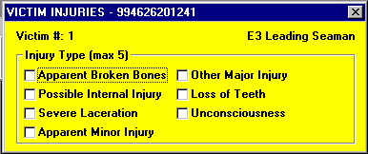

- Injury Type. Select the box(es) that describe the type(s) of bodily injury suffered by a person (i.e., "I" = Individual was entered into Type of Victim) who was the victim of one or more of the following offenses:

  - Offenses

    - Kidnaping/Abduction
    - Forcible Rape
    - Forcible Sodomy
    - Sexual Assault With An Object
    - Forcible Fondling
    - Robbery
    - Aggravated Assault
    - Simple Assault
    - Extortion/Blackmail

  - Authorized entries: (enter up to 5)

    - None
    - Broken Bones
    - Possible Internal Injury
    - Severe Laceration
    - Minor Injury
    - Major Injury
    - Loss of Teeth
    - Unconsciousness

  - Example (1): The offender assaulted the victim with a tire iron, breaking the victim's arm and opening up a cut about three inches long and one inch deep on his back. The entries should be Apparent Broken Bones and Severe Laceration.

  - Example (2): The victim, a respected religious figure, is blackmailed regarding his sexual activities. As he suffered no physical injury, the entry should be None.

SECTION V – VICTIM

Relationship to Suspects

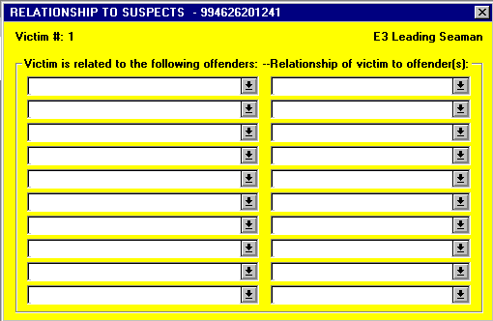

- Victim Related to Suspect#. Select the appropriate boxes to indicate the victims association with which suspect(s) number. More than one box may be selected if victim is related to additional suspect. Up to 10 suspect number boxes may be selected per victim.

  - Example: Victim 001 is related to Suspect No. 1, Aggravated Assault, however not related to Suspect No. 2, only box number “1" should be selected. However, if Victim 001 is related to both Suspect No., both boxes “1" and “2" should be selected.

- Relationship(s) of Victim to Suspect(s). This section is used to report the relationship between the victim and the suspect who committed a "Crime Against Person".

  - Therefore, this section is to be used only if one or more of the following offenses:

    - Murder and Non-negligent Manslaughter
    - Negligent Homicide
    - Justifiable Homicide
    - Kidnaping/Abduction
    - Forcible Rape
    - Forcible Sodomy
    - Sexual Assault With An Object
    - Forcible Fondling
    - Robbery
    - Aggravated Assault
    - Simple Assault
    - Intimidation
    - Incest
    - Statutory Rape

  - This section is to be used to indicate the victim's relationship with up to ten (10). Suspects involved in the incident. If multiple suspects are involved in a offense the Suspect/Arrestee Number should be entered into the box next to the Relationship of Victim to Suspect.

  - Authorized entries: (enter up to 10)

    - WITHIN FAMILY:

      - Victim Was Spouse
      - Victim Was Common-Law Spouse
      - Victim Was Parent
      - Victim Was Sibling (brother or sister)
      - Victim Was Child
      - Victim Was Grandparent
      - Victim Was Grandchild
      - Victim Was In-law
      - Victim Was Stepparent
      - Victim Was Stepchild
      - Victim Was Step Sibling (stepbrother or stepsister)
      - Victim Was Other Family Member

    - OUTSIDE FAMILY BUT KNOWN TO VICTIM:

      - Victim was Acquaintance
      - Victim was Friend
      - Victim was Neighbor
      - Victim was Babysittee (the baby)
      - Victim was Boyfriend/Girlfriend
      - Victim was Child of Boyfriend or Girlfriend
      - Homosexual Relationship
      - Victim was Ex-Spouse
      - Victim was Employee
      - Victim was Employer
      - Victim was Otherwise Known

    - NOT KNOWN BY VICTIM:

      - Relationship Unknown
      - Victim was Stranger

    - Victim is Offender

  - Example (1): An employee assaulted his employer (a person) with his fists. Victim Was Employer should be selected.

  - Example (2): Two unknown suspects rob a male and female couple. Victim Was Stranger should be entered to indicate the relationship of each victim to each offender.

  - Example (3): The victim is assaulted by two suspects, Suspect #1 is the victim’s brother and Suspect #2 was the victim’s friend. In the box next to Sibling, enter “01", in the box next to Friend, enter “02”.

SECTION VI – WITNESS/SPONSOR

This section is used for the recording of information describing a witness(es) or sponsor(es) of an incident/offense only when the witness(es)/ sponsor(s) is not the victim or complainant.

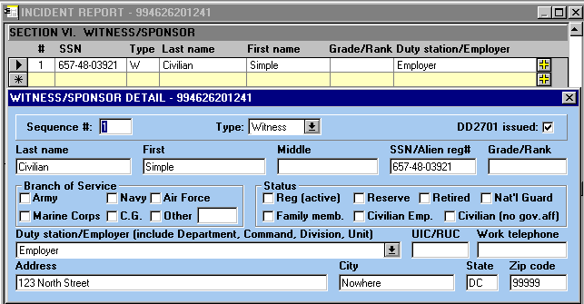

- Type/Sequence Number. Select either Witness or Sponsor to identify the individual as related to the incident report. Each witness or sponsor in an incident is to be assigned a sequence number from "01" to "99."

- DD 2701 Issued. Refer to Victim Section.

- Last Name, First, Middle. Refer to Complainant Section.

- SSN/Alien Registration Number. Refer to Complainant Section.

- Grade/Rank. Refer to Complainant Section.

- Branch of Service. Refer to Complainant Section.

- Status. Refer to Complainant Section.

- Duty Station/Employer. Refer to Complainant Section.

- UIC/RUC. Refer to Complainant Section.

- Work Phone. Refer to Complainant Section.

- Address. Refer to Complainant Section.

- City. Refer to Complainant Section.

- State. Refer to Complainant Section.

- Zip Code. Refer to Complainant Section.

SECTION VII – SUSPECT/ARRESTEE

This section is used for the recording of information describing suspects and arrestees of an incident/offense. When an arrest is made, Suspect and Arrestee information must be completed.

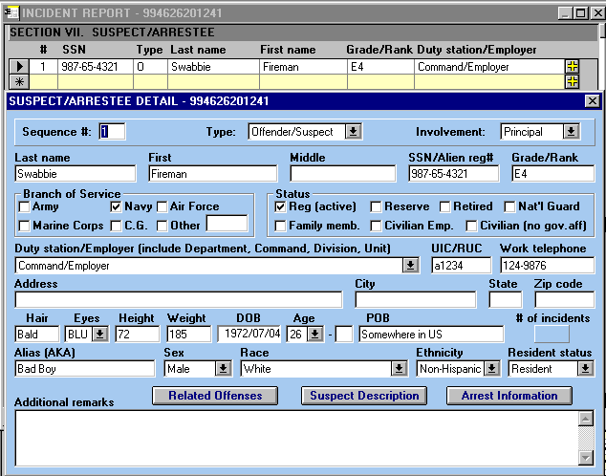

- Sequence Number. Select either Suspect or Arrestee to identify the individual as related to the incident report. Each suspect/arrestee in the incident is to be assigned a sequence number from "01" to "99."

- Suspect/Arrestee. Select the appropriate box(es) to identify the individual listed in this section as either a suspect or an arrestee. If the individual is suspect and is also arrested both blocks should be checked. See explanations above for various situations.

  - Example: An individual is observed by security patrolman breaking into a parked vehicle, the suspect is arrested by the patrolman, the Arrestee blocks should be checked.

  - Example (2): Two offenders were seen fleeing the scene of a burglary, but because they were wearing ski masks, their age, sex and race could not be determined. Two “Suspect/Arrestee sections” should be submitted -- one with Suspect/Arrestee #: "01" and the other with "02". "Unknown" should be selected or entered into Sex, Race, and DOB blocks.

- Involvement. Select the appropriate box to indicated the suspects/arrestees involvement in the commission of the offense.

  - Authorized entries: (select only one)

    - Principal - selected if the suspect/arrestee acted alone in the commission of the offense.
    - Conspirator - selected if the suspect/arrestee
    - Accessory - selected if the suspect/arrestee is not considered the chief actor in the offense, nor was he present at its performance, but he is considered as contributing or aiding in the commission of the offense.
    - Solicitor - select if the suspect/arrestee solicited or advised another person or persons to commit a offense.

- Last Name, First, Middle. Refer to Complainant Section.

- SSN/Alien Registration Number. Refer to Complainant Section.

- Grade/Rank. Refer to Complainant Section.

- Branch of Service. Refer to Complainant Section.

- Status. Refer to Complainant Section.

- Duty Station/Employer. Refer to Complainant Section.

- UIC/RUC. Refer to Complainant Section.

- Work Phone. Refer to Complainant Section.

- Address. Refer to Complainant Section.

- City. Refer to Complainant Section.

- State. Refer to Complainant Section.

- Zip Code. Refer to Complainant Section.

- Hair Color. Enter the predominant natural hair color. The color observed should be checked against the color shown on the individual’s identification card or drivers license. If the hair has been dyed, make an appropriate entry, such as “brown-dyed red”. If the person is completely bald (be alert for wigs and toupees), enter “Bald”. In the case of partial baldness, the color of the hair is entered and a remark is made in the Identifying Marks block on the extent of baldness.

- Eye Color. Enter the color of the iris of the eye. It is incorrect to enter the condition, such as “bloodshot”. If unknown, leave blank. The standard colors and authorized abbreviations authorized:

  - Authorized entries:

    - BRN - Brown
    - BLU - Blue
    - HAZ - Hazel
    - GRN - Green
    - GRY - Gray

- Height. Enter the Suspect’s/Arrestee’s height in feet and inches (e.g., 6'2"). If unknown, leave blank.

- Weight. Enter the Suspect’s/Arrestee’s weight in pounds (e.g., 180). If unknown, leave blank.

- DOB (Date of Birth). Refer to Victim Section.

- POB (Place of Birth). Refer to Victim Section.

- Alias (AKA). Enter known alias used by Suspect/Arrestee. Indicate if none or unknown.

  - Example: Individual real name is “Joseph Doe” however he has also gone by the name “John Doe”. “JOHN DOE” should be entered in the Alias block.

- Sex. Refer to Victim Section.

- Race. Refer to Victim Section.

- Ethnicity. Refer to Victim Section.

- Resident Status. Refer to Victim Section.
SECTION VII – SUSPECT/ARRESTEE (cont’d)

Relationship to Offenses

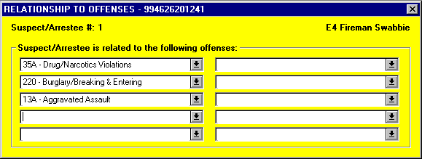

- Suspect/Arrestee Related to Offense #. Fill in the appropriate boxes to indicate specific offense(s) associated with the suspect or arrestee. More than one box may be selected if victim is related to additional offenses. Up to 10 offense boxes may be selected per suspect/arrestee.

  - Example: Suspect 01 is related to Offense No. 1, Drug/Narcotics Violations; Offense No. 2 Burglary/Breaking & Entering; and Offense No. 3 Aggravated Assault so all three offenses should be selected.

SECTION VII – SUSPECT/ARRESTEE (cont’d)

Suspect/Arrestee Description

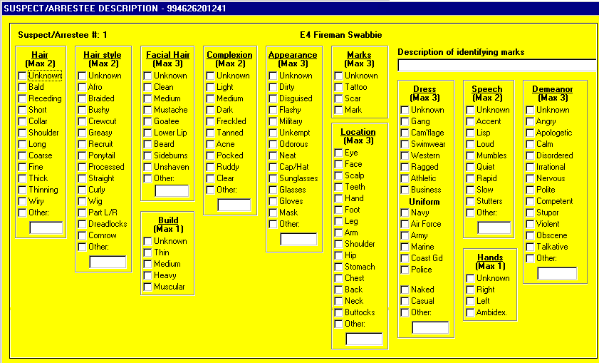

- Description. Select all appropriate box(es) as they apply to the description of the suspect/arrestee.

- Description of Identifying Marks - Enter any identifying marks, such as partial baldness, scars and tattoos together with their location on the body and a brief description. Give a word description rather than a diagram or picture. If there are no identifying marks, enter “None”.

  - Example (1): Partially bald, 2" diameter back of head

  - Example (2): Tattoo, Heart, right bicep

  - Example (3): Scar, 3" left inner wrist

SECTION VII – SUSPECT/ARRESTEE (cont’d)

Details of Arrest

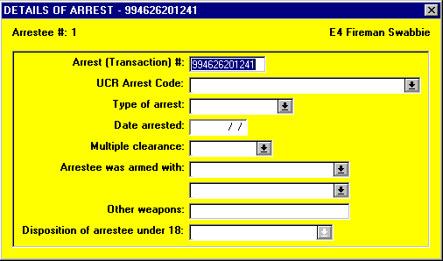

- Type of Arrest. Indicate how the Arrestee was arrested.

  - Authorized entries: (enter only one)

    - On-View (taken into custody without a warrant or previous incident report)
    - Summoned/Cited (not taken into custody)
    - Taken Into Custody (based on warrant and/or previously submitted incident report)

  - Example (1): The subject was arrested while in the act of soliciting for prostitution on a street corner. The entry should be “On-View Arrest”.

  - Example (2): The suspect was served with a traffic summons to appear in court. The entry should be “Summoned/Cited”.

  - Example (3): The subject was taken into custody as the result of a complaint being filed. The entry should be “Taken Into Custody”.

- Date Arrested. Enter the Year, Month, Day (YYYY/MM/DD) when the arrest took place.

  - Example: If the subject was arrested on July 23, 1989, the entry should be "1989/07/23".

- Multiple Clearance. Indicate whether or not the arrest of the Arrestee resulted in the clearance of more than one previously reported incident/offense within the jurisdiction served by the security department. If so, it is important to indicate that there was only one Arrestee responsible for the Multiple clearances of previously reported incident/offense. This is done by entering Multiple into all but one of the Arrestee Only section used to update the affected Incident Reports, and by entering Count Arrestee into the remaining Arrestee Only section. If the arrest did not result in multiple clearances, enter Not Applicable.

  - Authorized entries: (enter one per Arrestee Only Section).

    - Multiple
    - Count Arrestee
    - Not Applicable

  - Example (1): After the suspect’s arrest for robbery, it was learned that he was also responsible for five additional robberies within the jurisdiction of Naval Base Norfolk. One Arrestee Only section was marked “Count Arrestee”. The other five robberies the suspect was responsible for are marked “Multiple”.

  - Example (2): If the suspect's arrest did not clear additional incidents, the entry should be “Not Applicable”.

- Arrestee Was Armed With. Indicate whether the Arrestee was armed with a commonly known weapon at the time of his/her arrest. Up to two (2) entries may be made. If the weapon was an "automatic" firearm, an "A" will be entered into the block next to the appropriate weapon. Refer to the “Offense Section” for definition of "Automatic Firearm".

  - Authorized entries: (enter up to 2)

    - Unarmed
    - Handgun – manual
    - Handgun – semi-automatic
    - Handgun - automatic
    - Rifle – manual
    - Rifle – semi-automatic
    - Rifle - automatic
    - Shotgun – manual
    - Shotgun – semi-automatic
    - Shotgun - automatic
    - Lethal Cutting Instrument (e.g., switchblade knife, martial arts "stars," etc.)
    - Club/Blackjack/Brass Knuckles
    - Other (specify)

  - Example (l): When the suspect was Arrested, he had in his possession a .357 Magnum handgun and a penknife. The entry should be “Handgun”. Because a small pocket knife is not generally considered to be a "weapon," it does not qualify for reporting.

  - Example (2): The suspect resisted arrest using a liquor bottle and a chair as weapons before being subdued. The entry should be “Unarmed”. Although the subject used items as weapons, they were not commonly known weapons. This information should be entered into the Narrative Section of the Incident Report.

- Disposition of Juvenile. Complete this block only if the arrestee was 17 years of age or younger at the time of the arrest.

  - Authorized entries: (enter only one)

    - Handled Within Department (e.g., released to parents, released with warning etc.)
    - Referred to Other Authority (e.g., turned over to juvenile court, probation department, welfare agency, other police agency, criminal or adult court, etc.)

  - Example (1): The suspect, age 13, who was arrested for vandalizing a school, was released to his parents with a warning. “Handled Within Department” would be selected.

  - Example (2): The suspect, age 17, who was arrested for murder, was turned over to civilian authorities to be tried as an adult. “Referred to Other Authorities” would be selected..
SECTION VIII – ADDITIONAL POLICE OFFICERS

This section is used for the recording of information describing the responding security police officer’s/MP’s to the incident/offense. Do not list the Reporting Officer’s information in this section.

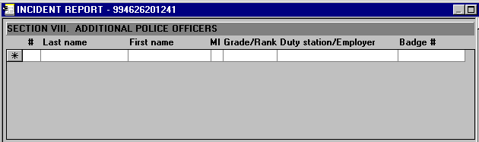

- Sequence Number. Each responding police officer/MP in an incident is to be assigned a sequence number from "01" to "99."

- Last Name, First, Middle. Refer to Complainant Section.

- Grade/Rank. Refer to Complainant Section.

- Duty Station/Employer (include Department/Command/Division/ Unit, etc.). Refer to Complainant Section.

- Badge #. Enter the individual security police officer’s/MP’s badge number, if assigned. If no badge number is assigned leave blank.
SECTION IX - NARRATIVE

This section is for the recording of additional information not listed elsewhere in the Incident Report. This section should list the chronology of events including the specific elements of the offenses reported in the Offense Section of the same Incident Report.

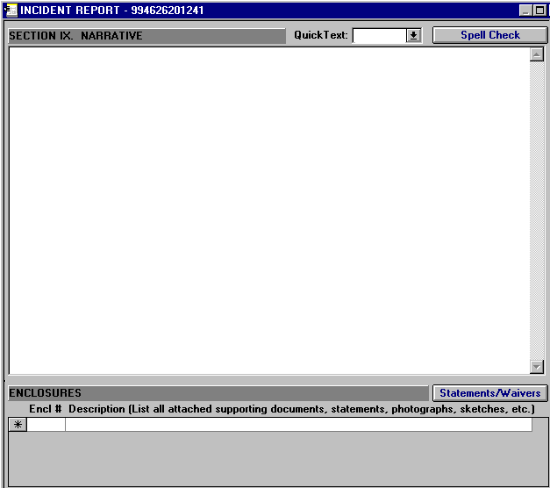

- Start with the Origin, how you responded, came to be at the incident.

- Next type the details of the report.

  - List only the facts of the incident. Do not include your opinions or conclusions.

  - Example: The victim was unconscious face down in the grass with her head to the north and her feet towards the south. The contents of her purse were dumped on the ground, approximately 15' west of her left shoulder.

- Quick Text. A block entitled Quick Text is included, to standardize report entries and provide a way to minimize typing required by the reporting officers.

  - Select the appropriate entry for the type report being written and the text is inserted into the report.

  - The reporting officer then will edit the text to reflect the information specific to his/her report.

  - Example: Quick Text for DUI

Officer __________ initiated a traffic stop at __________. __________ approached the driver, later identified as __________ and requested driver's license, proof of insurance and registration. __________ smelled a strong odor of an alcoholic beverage emanating from the suspect's breath.

At about ____, __________ asked __________ to exit his vehicle. __________ advised __________ that he was suspected of driving under the influence of alcohol and asked __________ if he would be willing to submit to a series of FIELD SOBRIETY TESTS (FST'S) to determine his ability to operate a motor vehicle. __________ stated that he would submit to the tests. __________ asked __________ if he was taking any medication or had any physical handicaps that would prevent him from satisfactorily completing any or all of the tests. __________ replied "No".

At about ____, __________ administered the FST'S to __________. The tests were conducted on level, undamaged asphalt which was well lighted. Prior to each of the tests, __________ explained and demonstrated the test and asked the suspect if he understood. __________ stated that he understood each of the tests. The suspect's performance of the tests was witnessed by __________.

Test #1 - Walking a straight line: __________ was asked to walk in a straight line along a painted white line on the road, keeping his hands to his side, touching heel-to-toe, for ten paces; then turning on the balls of the feet and walking nine paces back in the same manner. During the performance of this test, ...

Test #2 - Standing balance test: __________ was asked to stand in an erect position with his arms to his side, feet together, head tilted up and back slightly with eyes closed. __________ was instructed to remain in this position for approximately ___ seconds. During the performance of this test, ...

Test #3 - Finger-to-nose: __________ was asked to stand with his arms held out to his side and horizontal to the ground with index fingers pointed away from his body. __________ was instructed to bring the requested hand out in front of him, bend the arm at the elbow, touch the tip of his nose with the pointed finger then immediately return his hand to the original position by reversing the procedure. During the performance of this test, ...

Test #4 - Finger coordination test: __________ was instructed to use the hand of his choice and count the fingertips of that hand with the thumb of that hand starting with the index finger and counting out loud down to the pinky finger "one, two, three, four". __________ was then instructed to count out loud back up to the index finger starting with the pinky finger "four, three, two, one". __________ was instructed to repeat the process until told to stop. During the performance of this test, ...

Test #5 - Palm coordination test: __________ was asked to place his hands in front of him, with one hand facing up and one down, palm to palm. __________ was then instructed to flip the upper hand above the lower hand, turning it over and counting out loud with each repetition until instructed to stop. During the performance of this test, ...

Test #6 - Alphabet test: __________ was instructed to recite the letters of the English alphabet. While reciting the letters, ...

Officer __________ told __________ that he had failed ____ of the FST's and was under Military Detainment for suspicion of driving under the influence of alcoholic beverages. __________ conducted a pat down search of __________ for possible weapons, found none, and placed him in double locked handcuffs.

At about ____, __________ read __________ the California Implied Consent law which requires that he choose either a blood, breath, or urine test to determine his Blood Alcohol Concentration (BAC). __________ opted to take the ________ test.

At about ____, Officer __________ administered the first ________ test to __________ with the result of ...

- Enclosure(s)

  - Enclosure #. Enter the enclosure number of attached supporting documents (i.e., 01).

  - Description. Enter a brief description of attached supporting documents, (i.e., statements, photographs, sketches, etc.).

    - Example:

      - (01) Statement of Williamson (witness)
      - (02) Rough Sketch of Crime Scene

VOLUNTARY STATEMENTS

This section is used to record statements from Complainants, Victims, Witnesses, and Suspects. It can be used as the individual is actually making the statement or if statement is taken in the field the information can be typed in when report is written.

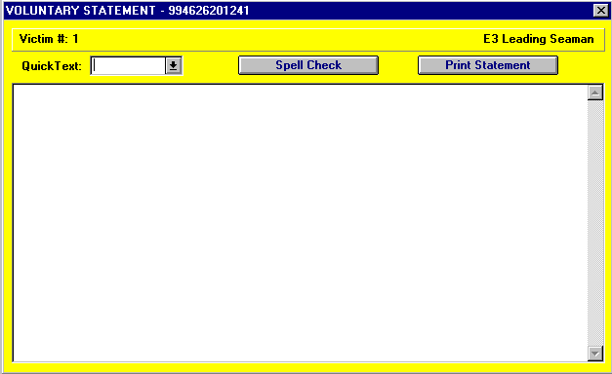

- Voluntary Statement

  - Provides an electronic copy of individuals statement.

  - Is not an official statement, as it is not signed.

  - If entered as individual makes statement, can be reviewed, corrections made, and then printed for individuals signature.

  - Quick Text is provided to select Voluntary Statement template.

    - Example of Voluntary Statement Quick Text

VOLUNTARY STATEMENT

I, ___________________, make the following free and voluntary statement to _____________, whom I know to be a ________________. I make this statement of my own free will and without any threats or promises extended to me. I fully understand that this statement is given concerning my knowledge of

Subscribed and sworn on __________________ Date _______ Time _______

__________________________ _________________________
Signature Signature
WAIVER OF RIGHTS

This section is used to record Waiver of Rights from Suspects prior to questioning and civilian employees prior to questioning during Administrative Investigations. It was designed to create Waiver of Rights forms for signature.

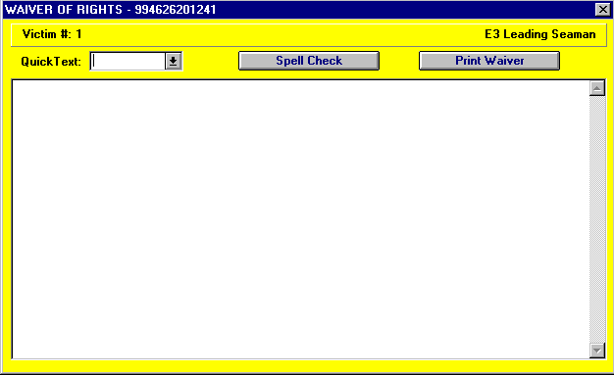

- Waiver of Rights

  - Provides an electronic copy of individuals Waiver of Rights.

  - Is not an official Waiver of Rights, as it is not signed.

  - After creating, Waiver of Rights can be printed for individuals signature.

  - Quick Text is provided to select Waiver of Rights template.

    - Waiver of Rights Quick Text forms

      - Civilian – Rights under the 5th Amendment
      - Military – Rights under Article 31b of the UCMJ
      - Civilian Employee – Used during Administrative Investigations. Authority derived from Title 44 United States Code, Section 3101; and Title 5 United States Code, Section 301 Departmental Regulations

    - Example of Civilian Waiver of Rights Quick Text

CIVILIAN SUSPECT'S ACKNOWLEDGEMENT AND WAIVER OF RIGHTS

Place:

I, , have been advised by that I am suspected of

I have also been advised that:

(1) I have the right to remain silent and make no statement at all; (2) Any statement I do make can be used against me in a court of law or other judicial or administrative proceeding; (3) I have the right to consult with a lawyer prior to any questioning. This lawyer may be a civilian lawyer retained by me at no cost to the United States, or, if I cannot afford a lawyer, one will be appointed to represent me at not cost to me. (4) I have the right to have my retained or appointed lawyer present during this interview; and (5) I may terminate this interview at any time, for any reason.

I understand my rights as related to me and as set forth above. With that understanding, I have decided that I do not desire to remain silent, consult with a retained or appointed lawyer, or have a lawyer present at this time. I make this decision freely and voluntarily. No threats or promises have been made to me.

Signature: ___________________________ Date & Time: ___________________________

Witnessed: _________________________ _______________________________________

Date & Time: ___________________________

At this time, I, desire to make the following voluntary statement. This statement is made with an understanding of my rights as set forth above. It is made with no threats or promises having been extended to me.

    - Example of Military Waiver of Rights Quick Text

MILITARY SUSPECT'S ACKNOWLEDGEMENT AND WAIVER OF RIGHTS

Place:

I, , have been advised by that I am suspected of

I have also been advised that:

(1) I have the right to remain silent and make no statement at all;
(2) Any statement I do make can be used against me in a trial by court-martial or other judicial or administrative proceeding;
(3) I have the right to consult with a lawyer prior to any questioning. This lawyer may be a civilian lawyer retained by me at no cost to the United States, a military lawyer appointed to act as my counsel at no cost to me, or both;
(4) I have the right to have my retained civilian lawyer and/or appointed military lawyer present during this interview; and
(5) I may terminate this interview at any time, for any reason.

I understand my rights as related to me and as set forth above. With that understanding, I have decided that I do not desire to remain silent, consult with a retained or appointed lawyer, or have a lawyer present at this time. I make this decision freely and voluntarily. No threats or promises have been made to me.

Signature: _____________________________ Date & Time: _____________________________

Witnessed: _________________________ ________________________________________

Date & Time: ___________________________
At this time, I, desire to make the following voluntary statement. This statement is made with an understanding of my rights as set forth above. It is made with no threats or promises having been extended to me.

    - Example of Civilian Employee Waiver of Rights Quick Text

ADMINISTRATIVE INVESTIGATION (CIVILIAN EMPLOYEES)

AUTHORITY: 44 U.S.C. 3101; 5 U.S.C. 301 Departmental Regulations

This investigation is being conducted to determine a possible violation of:

1. The purpose of this interview is to solicit response that will assist in determining whether disciplinary action is warranted, and the answers furnished may be used in disciplinary proceedings that could result in ADMINISTRATIVE action against an employee, INCLUDING DISMISSAL.

2. All questions relating to the performance of official duties must be answered fully and truthfully, and disciplinary action, including dismissal may be undertaken if an employee REFUSES TO ANSWER FULLY AND TRUTHFULLY.

3. No answer give nor any information gained by reason of such statements may as a matter of Constitutional Law, be admissible against an employee in any CRIMINAL PROCEEDING.

4. If an employee refuses to respond to such questions AFTER being given the above assurance and warning, there is no Constitutional bar to disciplinary action, including dismissal from employment, based upon such refusal.

5. I understand my rights as related and set forth above.

NAME: _________________________ ______________________________________ SIGNATURE

DATE & TIME: ____________ CASE: _______________________________

WITNESSED: _____________________________________

DATE & TIME: ___________________________________

Investigation Branch, Security Department
SECTION X - REPORTING/APPROVING OFFICIALS

This section is used to record information concerning the individuals preparing and approving the Incident Report.

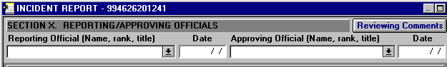

- Reporting Official. Enter the typed or printed name, rank, title and signature of the individual who prepared the Incident Report and date it was completed.

  - Example: John A. Adams, E-5, Patrolman

- Approving Official. Enter the typed or printed name, rank, title, and signature of the supervisor who reviewed and approved the contents of the Incident Report and date is was reviewed and approved.

  - Example: John A. Adams, E-8, Asst. Security Officer
REVIEWERS COMMENTS

This section is provided for Approving Official to annotate problems with report for Reporting Officer to correct or for anyone in the review chain to make comments for higher authority that are not in report.

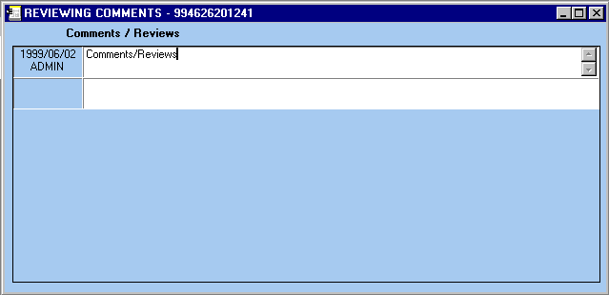

- Comments/Reviews

  - Date of comment and by whom

  - Comments

