

Installing STARS on ISNS workstations in
compliance with IT-21 standards:
NOTE: | Because STARS contains sensitive information, not all workstations on board should have access to STARS. You should only configure a limited number of authorized workstations.
STARS can be installed either as a standalone application or as a client/server application.
As a standalone application, STARS is installed on individual workstations, where each individual workstation accesses a database which is unique to the workstation. In the ISNS/IT21 standalone environment, all files reside on the C: drive of the workstation.
As a client/server application, the STARS application and database files are installed on a file server that is accessed by all the network workstations installed with STARS. In the ISNS/IT21 client/server environment, the application driver files reside on the C: drive of the individual network workstations, while the application and database reside on the shared S: drive on a network server that is assessable from all workstations.
The following instructions are addressed:
Instruction Page
Downloading The Installation Software And Documentation 1
Installing Software On The Workstation (Standalone & Client) 3
Installing Software On A Shared Network File Server 6
Creating A Desktop Shortcut 7
Migrating From A Previous Release Of STARS 8
Executing STARS 9
Uninstalling STARS 12

Downloading The Installation Software And Documentation
NOTE: | Steps 1, 2 and 3 below should be completed while you are in port only. The rest of the steps below can be done in port or while at sea.
Step 1: | Log onto your computer workstation with a domain login, which will provide you access to your ship’s network. Verify that you can find the S: drive using Windows Explorer. Create a folder on the S: drive named WINSTARS.
Step 2: | Open Internet Explorer. Go to the website www.zoa.com. Click the Download button to go to ZOA’s software download page. On ZOA’s download page, select Full installation for STARS 2.19.  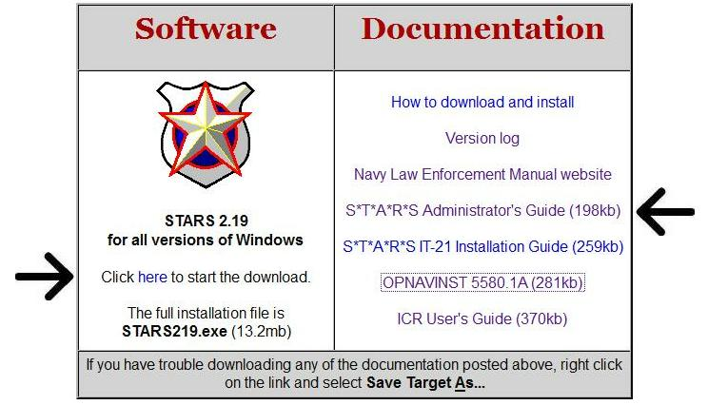  You will be downloading a 13 mb file having the name STARS219.EXE. Save this file to the folder created in Step 1, S:\WINSTARS.  While you are visiting ZOA’s download page, download the STARS Administrator’s Guide. You will need this 33-page book to administer STARS. If you think your Masters at Arms might benefit from some instructions on how to fill out their Incident Reports, you should also download the ICR User’s Guide. Both the STARS Administrator’s Guide and the ICR User’s Guide can be saved in the S:\WINSTARS folder for shared access.  Be sure to download all the files you need while in port and during non-peak network usage hours. Do not attempt to download any of these files while at sea via an internet satellite link as the satellite link may not be stable.
Step 3: | Your ship has been provided with a STARS key registration file named HEADERS.TXT. This is a small, encrypted file, which provides your copy of STARS with the required software licensing information to make your software work. This file also contains your ship’s name and your UIC.  If you already have a working copy of STARS, you can find the HEADERS.TXT file in the subdirectory (i.e. folder) where your current copy of WINSTARS.EXE is installed. If you cannot find your HEADERS.TXT file, send an email to help@zoa.com requesting a copy of your key file. When you send your email, be sure to provide your ship’s name and UIC. ZOA Consulting will provide you with a copy of your key file via email.  After you’ve acquired your HEADERS.TXT file, copy this file to S:\WINSTARS.

Installing Software On The Workstation (Standalone & Client)
NOTE: | Steps 4 through 14 should be completed on all workstations. Step 14 should be repeated for each user of a workstation.
Step 4: | At any workstation on board, login as a domain user so that you will have access to server resources on the shared S: drive.
Step 5: | Use Windows Explorer to create a folder on your C: drive named ZOA. This is a temporary folder where you will place the STARS installation kit.
Step 6: | Use Windows Explorer to copy S:\WINSTARS\STARS219.EXE to C:\ZOA. Be sure that you copy the STARS219.EXE file to your C: drive. Do not just create a shortcut in C:\ZOA for S:\WINSTARS\STARS219.EXE.
Step 7: | If you are installing STARS on Windows 2000, proceed to Step 8a. NT 4.0 workstation users should use the Start button at the bottom left corner of your screen, select Shut Down and then Restart to login as a different user. When you are prompted to log back into Windows NT, login with a local (not domain) user ID. You should not be connected to the network.
Step 8a: | Use Windows Explorer to find and execute C:\ZOA\STARS219.EXE. This is the self-extracting file that installs STARS and its related library files to your computer. Follow the instructions in the pop-up boxes shown below, accepting the defaults:  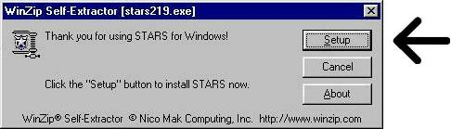  Click the default Setup button and wait the next pop-up box to appear.
Step 8b: | Make sure that all other applications are closed before clicking OK as shown.  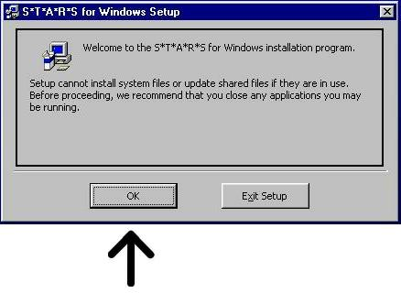
Step 8c: | If you are installing STARS on a Windows 2000 workstation skip to the next step (Step 8d). On Window NT 4.0 workstations, the follow message may appear. Acknowledge this message by clicking OK.  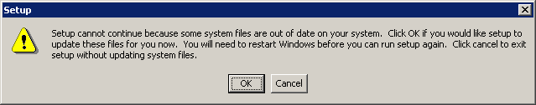
Step 8d: | About halfway through the installation process, after most of the files are extracted, you will be required to reboot your computer to update some system files. Reboot the computer when prompted to do so by clicking Yes.  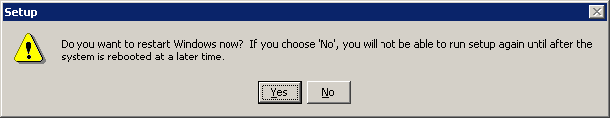  If installing at an NT 4.0 workstations, after your workstation has rebooted, login again as a local user OR if installing at a Windows 2000 workstations, after your workstation has reboot, login again as a domain/network user.
Step 8e: | Use Windows Explorer to find and execute C:\ZOA\STARS219.EXE again. Click Setup button to resume the installation process.
Step 8f: | If any applications are active, the following message will appear and should be acknowledged by clicking OK
Step 8g: | When prompted for a location to install STARS, accept the default directory of C:\Program Files\WINSTARS by clicking the installation icon/button as shown below.  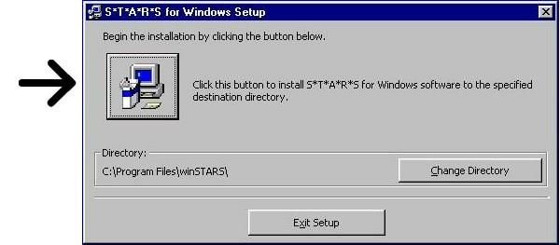
Step 8h: | Next, click the “Continue” button to accept the default group name.  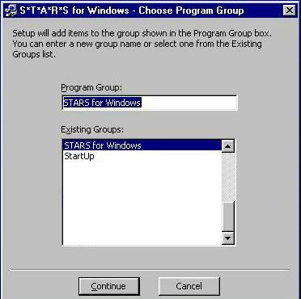
Step 8i: | Finally, click OK to acknowledge successful installation.  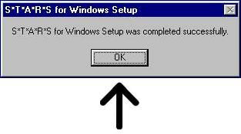  After completing steps 8a thru 8i above, you have installed STARS and its required library files on the C: drive for a standalone configuration.
Step 9: | If you are installing STARS on a Windows 2000 workstation, skip this step and proceed to the next step (Step 10). When installing to a Windows NT 4.0 workstation, use the Start button at the bottom left corner of your screen, select Shut Down and then Restart to login as a different user. When you are prompted to log back into your Windows NT, login with a domain (not local) user ID so that you will have network access.
Step 10 | You should delete the temporary file C:\ZOA\STARS219.EXE and the temporary folder C:\ZOA.  - If you are installing to a standalone workstation, proceed to the next step (Step 11).  - If you are installing to a client workstation and this is your first workstation skip to Step 12.  - If you are installing to a client workstation and this is NOT your first workstation, you should delete the file C:\Program Files\WINSTARS\WINSTARS.exe, then skip to Step 13.
Step 11 | The final step for installing STARS in a standalone environment is to copy the S:\WINSTARS\HEADERS.TXT file to the C:\Program Files\ WINSTARS folder.  Skip to Step 14 to configure a desktop shortcut.

Installing Software On A Shared Network File Server
NOTE: | This step only has to be done one time, after the first workstation is installed.
Step 12: | To use STARS in a multi-user shared environment, you must now copy the STARS program and data files to your server from the first workstation that has been installed.  Copy the seven files from C:\Program Files\WINSTARS to S:\WINSTARS. The names of these files are:  AMERICAN.VTD WINSTAR0.MDW CUSTOM0.DIC WINSTARS.EXE ST6UNST.LOG WINSTARS.HLP STRU2000.MDB  - Locate the HEADERS.TXT file that has been issued to your ship and copy it into S:\WINSTARS\HEADERS.TXT.  - Delete the file on the first workstation C:\Program Files\WINSTARS\WINSTARS.EXE.
Step 13: | On each client workstation, the link to the STARS application from the “Start” button on the task bar is incorrect. The link can be removed using Windows Explorer.  In a Windows NT 4.0 installation, use Windows Explorer to select the folder C:\winnt\profiles or in a Windows 2000 installation , use Windows Explorer to select the folder C:\Documents and Settings  Next select the folder belonging to your user-id. Once you have selected the folder belonging to your user-id, you can select the desktop folder.  In the desktop folder, right click the shortcut to “STARS for Windows”, and select the delete option to remove STARS for windows from the Start button selection path.  Continue to Step 14 to Configure a Desktop Shortcut.

Creating A Desktop Shortcut
NOTE: | Each STARS workstation user must create his/her own desktop shortcut.
Step 14: | Do the following to create a desktop shortcut which will execute STARS:  - Right click on the desktop to display the desktop dropdown box and select the “New” option to display the new option dropdown box.  - Select the “Shortcut” option to create a shortcut icon on the desktop and to activate the “Create Shortcut” Window.  - In the Create Shortcut Window, click the “Browse” button to locate the WINSTARS.EXE file. In the “Browse” window, do the following:  - Use the “Look In” drop down box to locate the folder where WINSTARS.EXE resides (Note: for standalone workstations this folder is C:\Program Files\WINSTARS and for networked client workstations this folder is S:\WINSTARS).  - In the “Files of Type” drop down box, select “All files”.  - In the File List pane, scroll through the list of files in the select folder until you find WINSTARS.EXE and click on it to select it.  - Click the “Open” button to select the file and close the “Browse” window.  - In the Create Shortcut Window, click the “Next” button to activate the “Select a Title for the Program” window and click the “Finish” button to accept the default title for the program.  Continue to Step 15 and/or 17 as necessary.

Migrating From A Previous Release Of Stars
Step 15: | If your users have been using STARS previously, you will want to migrate your old data into your new installation of STARS. Before you can migrate your data, you must first verify what version of STARS your users have been using. Go the computer or server where your existing STARS software is installed. Startup STARS. On the login screen, verify the version of STARS that is installed. You don’t need to login to STARS. Just note the version number.  - If you have version 1.48 or earlier, go to Step 16a.  - If you have version 2.00 to 2.19, go to Step 16b.  - If you don’t have a previous version of STARS or you don’t wish to migrate your old data forward into your new installation, go to Step 17.
Step 16a: | In your existing installation of STARS 1.xx, find the data file STARSDB.MDB  If you are installing either a standalone workstation or a shared network server, create the folder ZOA on the C: drive and copy the STARSDB.MDB file to C:\ZOA. DO NOT move the original file, as it will be your backup.  Continue to Step 17 and execute STARS to finish the migration.
Step 16b: | In your existing installation of STARS 2.xx, find the two files STARSDB.MDB and WINSTARS.MDW.  - If you are installing a standalone workstation, copy the STARSDB.MDB and WINSTARS.MDW files into C:\Program Files\WINSTARS.  - If you are installing a shared server, copy the STARSDB.MDB and WINSTARS.MDW files into S:\WINSTARS.  Continue to Step 17 and execute STARS to finish the migration

Executing STARS
Step 17a: | On your desktop, double-click on the STARS icon that you created to verify that it works. If you do not see the following message the very first time you run STARS, proceed to Step 17b. The short message telling you that STARS is checking and/or creating your database files. If you see this message, just click OK. When the process is concluded, double-click on the STARS desktop icon again. Proceed to Step 17c.  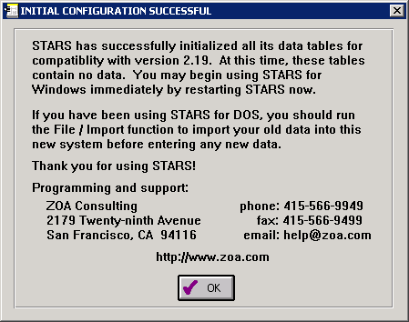
Step 17b: | If you do not see the following message proceed to the next step (Step 17c). This message means you have not installed the HEADERS.TXT file and are therefore not licensed to run the STARS application. After installing the missing HEADERS.TXT file, return to Step 17a.  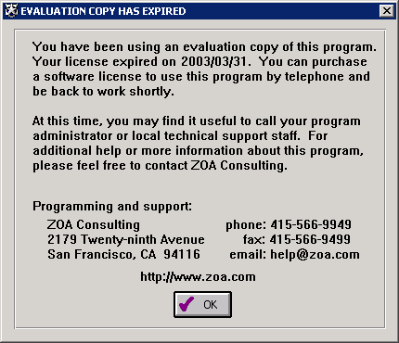
Step 17c: | You should now see the STARS login screen. It looks like this:  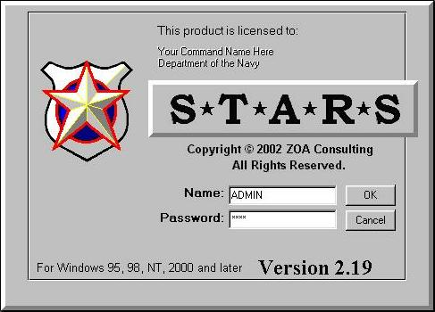  Enter your login user ID and password. If this is a new installation, the default login is:  Name: ADMIN  Password: 1234  - If you are migrating from STARS 1.XX then proceed to Step 18a  - If you are migrating from STARS 2.XX then proceed to Step 18b  - If you are not migrating from a previous version of STARS or are migrating from the current version of STARS proceed to Step 19
Step 18a: | If you followed Step 16a to copy your old STARS 1.xx data into C:\ZOA, you are ready to import the old data into your new installation. Be sure that you do this step before any users input data into STARS. Remember, you don’t need to do this step if your ship was using STARS version 2.xx.  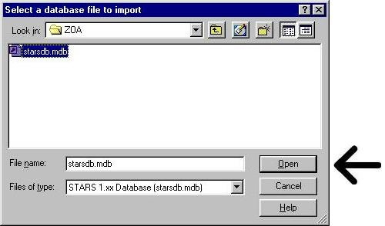  You should still be logged into STARS as the ADMIN user. Close any open data grids. From the top line menu, select File / Import / Import from STARS for Windows 1.xx. You will see a window like the one below:  Using the file window, find and select the STARSDB.MDB file, which is located in C:\ZOA. When you have found and selected this file, click the Open button. STARS will then automatically import and convert all your old 16-bit data into the 32-bit file formats used by STARS 2.19. This will take a few minutes. Be patient. You may delete C:\ZOA after the migration is complete. Proceed to Step 19.
Step 18b: | If you have moved existing STARS 2.xx data into this installation in Step 16b, then you will login using ADMIN and your current ADMIN password. Check with your STARS administrator to find out what the ADMIN password is.  If your login is successful, you should see a screen that has this menu bar at the top:  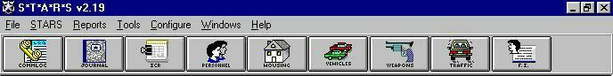  If you migrated STARS 2.xx data from your old installation via Step 16b, you should now be able to click on any of the graphic buttons in this menu bar and see your data. Click a few of the buttons to verify that you can see your data. (If you didn’t migrate any data, you won’t see any data, of course.) Proceed to Step 19.
Step 19: | You are at the end of basic the installation. Congratulations! You have now completed the installation of STARS 2.19 on your network and you have successfully setup one workstation to use STARS.  If you migrated from an existing installation of STARS 2.19, all your user IDs and passwords are in place along with your data. Your first user is ready to begin working at this workstation.  If you had no previous installations of STARS on board from which you migrated data or if you migrated from STARS 1.xx, then you should now consult the STARS Administrator’s Guide to learn about how to create user accounts, set passwords and assign permission groups. Until you create new STARS user accounts, set passwords and assign permission groups, your STARS installation is extremely vulnerable because you have only one high-level user (named ADMIN) with the standard default password of 1234.

Uninstalling STARS
Step 1: | - The server and all client workstations can be uninstalled (Step 2 once plus Steps 3 - 10 at each workstation) or …  - Individual client/standalone workstations can be uninstalled (Steps 3 - 10)
Step 2: | Uninstalling STARS on a Windows NT 4.0 server requires that any data files left in the S:\WINSTARS folder be saved or archived for future reference, since they contain legal information/records. Once this data has been save in backup/archive files, the S:\WINSTARS folder may be deleted.
Step 3: | Uninstalling STARS in an Windows NT 4.0 or Windows 2000 standalone workstation  - Log onto your computer workstation.  - Go to My Computer on the desktop.  - Open the Control Panel and select Add/Remove Programs.  - Select STARS for Windows.  - Click the Add/Remove Programs button.  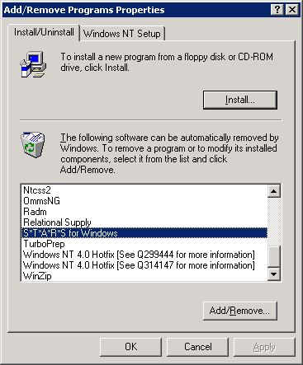
Step 4: | You will have to click Yes to verify that you wish to uninstall STARS  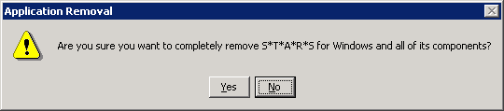
Step 5: | If the following screen appears on either a Window NT 4.0 or Windows 2000 standalone workstation during the uninstall process; ALWAYS CLICK THE KEEP BUTTON. This will prevent possibly shared drivers from being removed from your system and rendering other application inoperable.  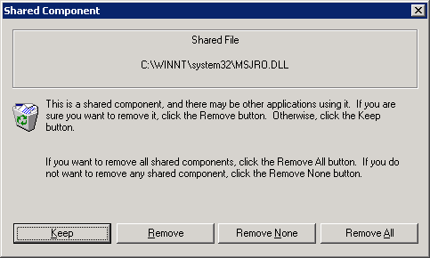  On a Windows NT 4.0 workstation, the above screen may appear once for each of these files:  MSADOX.DLL MSJRO.DLL MSBIND.DLL comdlg32.ocx  THREED32.ocx Vspell32.ocx MSMASK32.ocx MSADODC.oxc  ssdw3bo.ocx  On a Windows 2000 workstation, the above screen may appear once for each of these files:  MSADOX.DLL MSJRO.DLL MSBIND.DLL comdlg32.ocx  THREED32.ocx Vspell32.ocx MSMASK32.ocx MSADODC.oxc  ssdw3bo.ocx ssmedt32.dll sspm32.dll ssr2c.dll  MSCHRT20.ocx Vspell32.dll  If other file names appear in the above screen, just remember to click the keep button.
Step 6: | At the client workstations, if the following message appears, the message should be acknowledged by clicking OK.  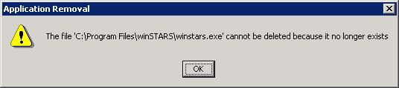
Step 7: | If the following message appears, files still exist in the STARS for Windows folder. These files should be backup up for future information and/or deleted if no longer needed. Click OK to acknowledge the message.  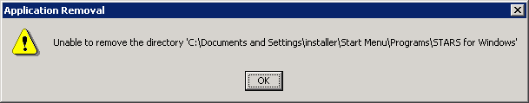
Step 8: | If any components cannot be removed (Steps 5, 6 and/or 7) the following message must be acknowledged by clicking OK.  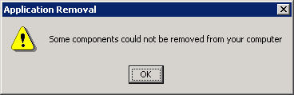
Step 9: | When the Uninstall is complete, the following message appears. Click OK.  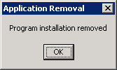
Step 10: | - Close the Add/Remove window and the Control Panel window.  - Delete all desktop shortcuts that point to STARS.  - On a standalone workstation, any data files left in the C:\Program Files\WINSTARS folder should be save for future reference, since they contain legal information/records  - On a client workstation, the folder C:\Program Files\WINSTARS and any file remaining in it may be deleted, since all data is maintained on the shared S: drive on the network file server.

